SWAN WHEELERS CYCLING CLUB Track Event
Derby Arena Velodrome – Friday 12th April 2024
We have organised an opportunity for those who have never ridden inside a velodrome or would like another go. It is a very different experience to riding on the road – the bikes have one fixed gear and no brakes! But don’t worry, it really is great fun, not to say exhilarating!!!
No equipment necessary – we can hire bikes and shoes (not needed if you have Look/Keo plates)
We will have one hour on the track supervised by a track coach to guide us and help us to get the most out of our session.
Booking:
Our track booking is 8.00 – 10.00 pm on Friday 12th April
Venue:
Derby Arena, Communities and Place, Leisure Culture and Tourism, Derby Arena, Royal Way, Pride Park, Derby, DE24 8JB Tel: 01332 640011 www.derby.gov.uk
Facilities:
1) Parking - is free for 3 hours at the Arena. When you go into reception tap your car registration into the touch pad
2) Arrival time - we can all meet in the cafe within the track area- we have access to the track area 30 mins before our session starts. So we can go in from 7.30pm
3) Changing facilities - these are available along with showers. Lockers take £1 coins
Costs:
£11.98 track + track coach hire for 16 riders
£13.98 track + track coach hire for 32 riders
£8.90 bike hire (I will need to provide details as per the form below)
£7.20 shoes (not needed if have Look/Keo plates)
Total cost per rider is £28.08 (16 riders) or £36.13 (32 riders)
Payment:
Costs for tack & coach hire will need to be paid in advance (date to be confirmed) to SWCC as follows:
Payee name: Swan Wheelers Cycling Club
Lloyds Bank
Sort code: 30-63-97
Account code: 22215160
Please add your name+Derby as the payment reference

Costs for bike/shoe hire are payable on the night to the Derby Arena.

Bike Hire sizing:
Please supply details as per the form below for height & shoe size (if shoes needed).
Send your details to Niall Brash at brashn@live.com
Any questions, please e-mail me or call on 07804-924493
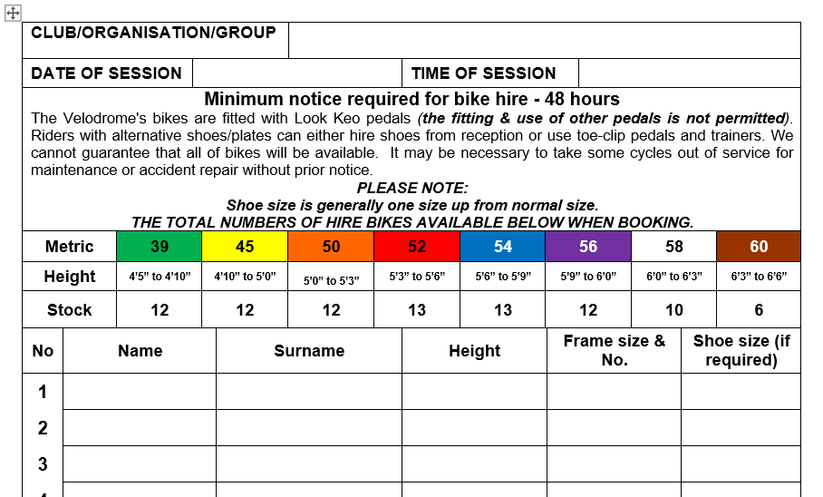

Niall Brash
SWCC
13.01.2024

