SWANS Track Event – Derby Arena Velodrome – Friday 20th January 2023
We have organised an opportunity for those who have never ridden inside a velodrome or would like another go. It is a very different experience to riding on the road – the bikes have one fixed gear and no brakes! But don’t worry, it really is great fun, not to say exhilarating!!!
No equipment necessary – we can hire bikes and shoes (not needed if you have Look/Keo plates)
We will have one hour on the track supervised by a track coach to guide us and help us to get the most out of our session.
Booking:
Our track booking is 8.00 – 9.00 pm on Friday 20th January
Venue:
Derby Arena, Communities and Place, Leisure Culture and Tourism, Derby Arena, Royal Way, Pride Park, Derby, DE24 8JB Tel: 01332 640011 www.derby.gov.uk
Car parking is available at the venue.
Costs:
BC Registered Club package
Track Hire (max 16 riders) | £152.00
Coach | £30.50
Bike | £8.50
Shoes | £6.90
Cost per rider | £26.81

The cost per rider assumes we have 16 riders. Individual cost would be less if you don’t hire shoes.
Bike Hire sizing:
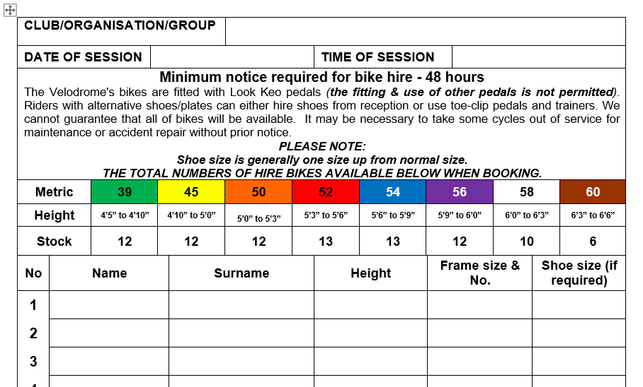
We will need to forward this information nearer the time.
PLEASE REGISTER YOUR INTEREST IN COMING TO DERBY BY HITTING THE ‘I’M ATTENDING’ BUTTON AS USUAL
ANY QUESTIONS – PLEASE ASK!

